


Lester B. Pearson High School

CGC1D – Geography of Canada (Academic) - Course Outline

Ms. K. Peterson | petersonk@hdsb.ca |  | http://chatt.hdsb.ca/~petersonk
Ms. K. Peterson | Office Hours: Period 2 |  | Classroom: 115 Office: T3
Mrs. H. Howell |  | howellh@hdsb.ca |  | http://chatt.hdsb.ca/~howellh
 |  | Office Hours: Periods 5 |  | Classroom: 115 Office: T4

This course explores Canada’s distinct and changing character and the geographic systems and relationships that shape it. Students will investigate the interactions of natural and human systems within Canada, as well as Canada’s economic, cultural and environmental connections to other countries. Students will use a variety of geo-technologies and inquiry and communication methods to analyze and evaluate geographic issues and present their findings.

Curriculum
Students final report card grade will be based on the evidence provided of these overall curriculum expectations:

- Describe the regional diversity and interactions of systems within and between Canada.
- Analyze local and regional factors affecting Canada’s natural and human systems.
- Explain the ways in which humans impact the environment and evaluate the outcomes of these interactions in terms of sustainability.
- Explain the economic, cultural and environmental connections between Canada and the World.
- Predict how future environmental, economic and social changes will affect Canada and the World.
- Use the methods and tools of geographic inquiry to locate, gather, evaluate, and organize information about Canada’s natural and human systems.
- Analyze and interpret data gathered in inquiries using a variety of methods and geo-technologies and communicate the results using appropriate terms, concepts and techniques.

Your Report Card Grade will be determined as follows:
Term work:  70% of your grade will be based on all of the evidence you have provided. It will reflect your most consistent level of achievement with special consideration given to more recent evidence. | 17% Knowledge & Understanding: Emphasizes the ability to recall factual information, recognize fundamental concepts and the foundational skills of the subject/discipline.  18% Application: Emphasizes the application and integration of knowledge, skills, processes and techniques to produce evidence of the student’s understanding.  17% Thinking: Emphasizes the thinking skills used in thinking processes to demonstrate the student’s understanding of information they have processed.  18% Communication: Emphasizes the clear, precise and effective use of oral, written and visual language to communicate the student’s understanding of information and ideas.
Final Evaluation:  30% of your grade will be determined at the end of the course. | 20% Performance Task
 | 10% Written Exam
Your final grade will be calculated by combining your Term (70%) grade and your Exam and Performance Task Evaluations (30%).

Academic Standards
It is your responsibility to provide evidence of your learning within established time-lines. Due dates for assignments and the scheduling of tests will be communicated well in advance to allow you to schedule your time. If you aren’t going to be able to follow an agreed upon time-line you should demonstrate your responsibility and organizational skills by discussing with your teacher the challenges you’re facing as far in advance of the deadline as possible.
It is your responsibility to be academically honest in all aspects of your schoolwork so that the marks you receive are a true reflection of your achievement.
Plagiarism is using the words, ideas or work of someone else without giving appropriate credit to the original creator. This is a form of cheating.
Consequences for not meeting these academic standards may include:
- Reporting the issue to your parents;
- Requiring you to complete the original or alternative work after school or during your lunch hour;
- Requiring you to complete an alternative assignment;
- Suspension;
- Assigning a “zero” for an assignment not completed prior to an agreed upon closure date;
- Mark deduction of 5% / day.

NOTE: the complete HDSB policies and administrative procedures for “Lates and Missed Assignments” and “Cheating and Plagiarism” policies may be found at www.hdsb.ca

Learning Skills & Work Habits
These learning skills and work habits will be taught, assessed and evaluated throughout the course.
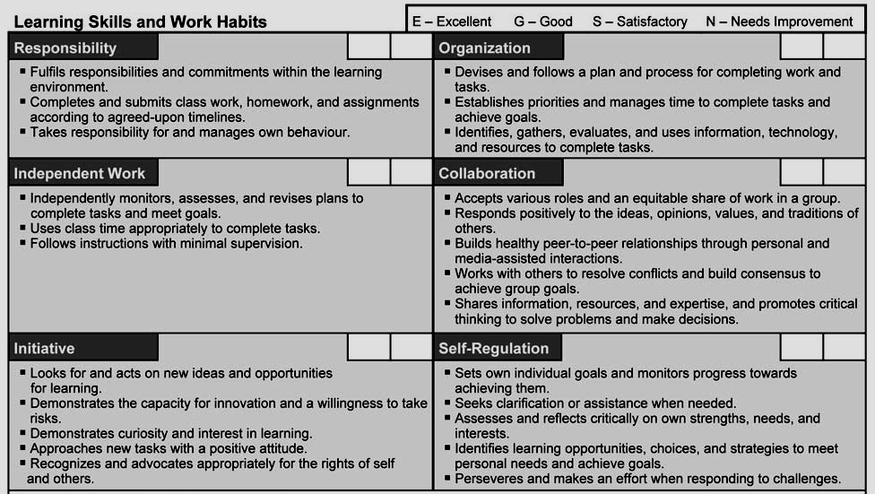

Unit Outlines
Units | Curriculum Focus | Major Assignments / Evaluations | Key Resources
1 Introduction to Geography and Skill Building | What is geography and how does it connect with different subjects?  Research, geo-technology and mapping skills. | Quiz  School Mapping Activity | - Text Chapters: 2-10  - Geo-technology Tools: Google Earth  - Library  - Maps
2 Physical Geography & its Natural Resources | How does Canada’s physical environment influence where we can find our natural resources?  What are the connections between the aspects of Canada’s physical geography?  How do Canada’s natural resource industries affect our lives? | Unit Test  Field Research Project  National Park Assignment  Geographic Writing & Research Skills Assignment (minor) | - Text Chapters:11-14,23-27,36  - Multimedia materials  - Geo-technology Tools: Google Earth & GPS  - Field Research Tools  - Atlas  - Library
3 Peoples of Canada | Who is the average Canadian?  How is Canada’s population changing and what does this mean for our future? | Unit Test  Statistics Canada Lab  Census Project | - Text Chapters:16-18  - Multimedia materials  - Stats Canada Data  - MS Excel  - Data Collection Tools
4 Urban Design | How are Canadian urban centers structured and how can we design them for a sustainable, livable future? | Quiz  Green Community Project (group)  Urban Field Trip / Project | - Text Chapters:19-2,28,30  - Multimedia materials  - Library  - Data Collection Tools
5 Canada's Connections to the World | What is Canada’s connection to the world, its role in the world and how has this changed over time?  What is the importance of understanding global issues?  How can a high school student practice active global citizenship? | Unit Test  Postcard from a Global Organization  Being a Global Citizen Assignment | - Text Chapters: 32-35  - Multimedia materials  - Library
6 Sustainability and Canada's Future | How does the human environment change and affect the natural environment and vice versa?  What does sustainability mean for Canada’s future?  What do you see as the most important issues facing Canada today and what can we, as a nation or as individuals, do about them? | Case Study Activities  Final Performance Task  Final Exam | - Text Chapters 37-39  - Library  - Multimedia materials

